The UHF reader uses the instructions

1, connecting devices and software
Connect the reader to your computer, double-click Open 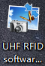Application, click the Read Format button, and the current format of the connected card reader will be displayed in the status box on the right side of the software.

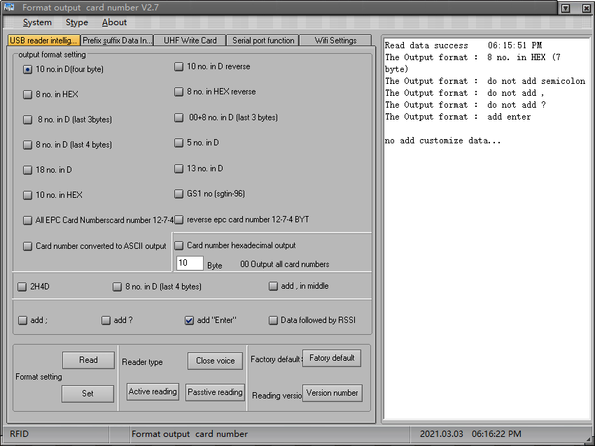
2. Format information is displayed here
1. Click here

If the connection fails, the following is the figure
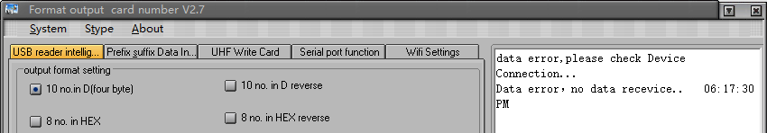

2, reader state output format
2.1 Output formatting
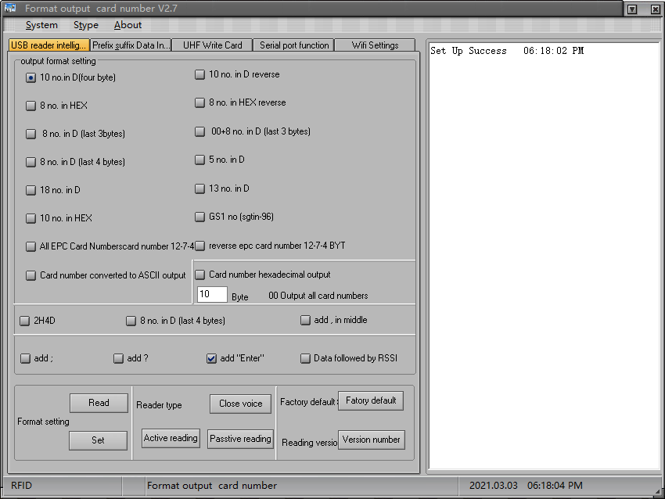
3. When the setting is successful, the status bar appears
1. Check the format you want to set
2. Click the Format button

2.2 Reader status settings
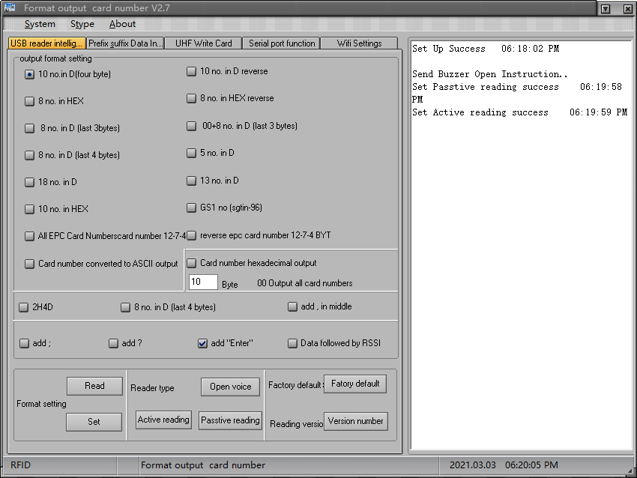
1. Set the reader status according to the requirements
2. When set, the results are displayed in the status window
2. Click the Format button
2.3 Restore the factory settings with the version number query
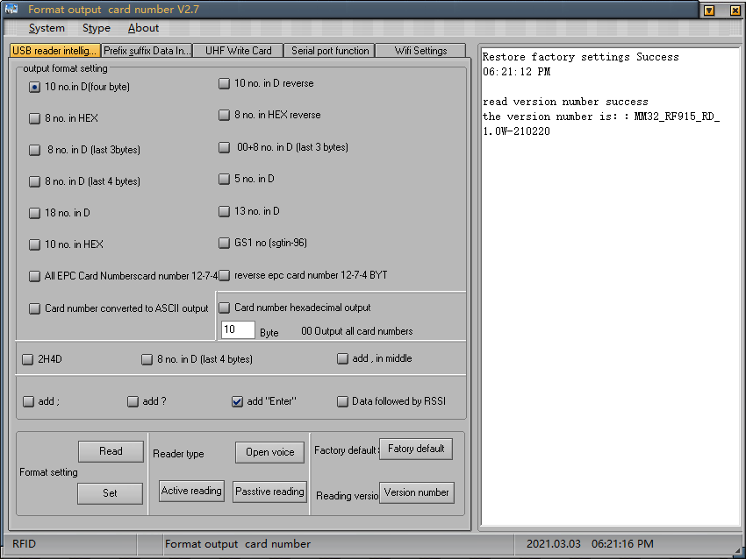
1. Click the corresponding button
2. The status bar shows the results

3, before and after the data input
3.1 prefix settings
Fill in the prefix and suffix that need to be added here, up to four bytes, and click the settings button after filling in to complete the setup, as shown in figure:
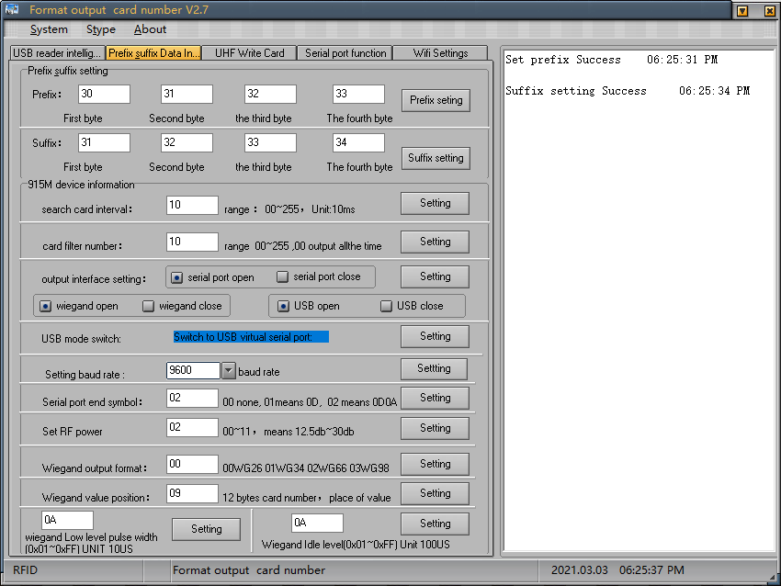
2. When the setting is successful, the results are displayed on the right
1. Enter the prefix and suffix you want to set, and then click the settings button on the right to confirm
3.2 915M machine information
The card-seeking interval value, which refers to the two card-reading intervals, and the longer the value, the longer the interval
The number of card filters, which refers to the number of reads of duplicate cards, and the longer the value, the longer the interval between repeated reads
Output interface settings, on demand to turn the interface on or off, the point settings button to complete the settings
USB keyboard mode switching, set to a USB virtual serial port, you need to enter the USB data debugging tab to operate, see the following instructions
Baud rate defaults to 9600, select thevalue you want and click the right-hand setting button to complete the setup
Add a serial input end character, enter the characters that need to be set in the input window, and set the dot setting button to complete the setup
RF power settings, the higher the value of the higher the power, the farther the sensing distance, enter the required value, click the settings button to complete the settings
Wigan output format, enter the corresponding value, represent the corresponding format, click the setting button to complete the settings
Weegan takes the value position,12 byte card number, fills in the required position, clicks the setting button to complete the setup
Wigan Low Pulse Wide Range and Wigan IdleLevel Pulse Wide Range, fill in the values that need to be set(0x01 to 0xFF),click the Settings buttonto complete the setup, as shown below:

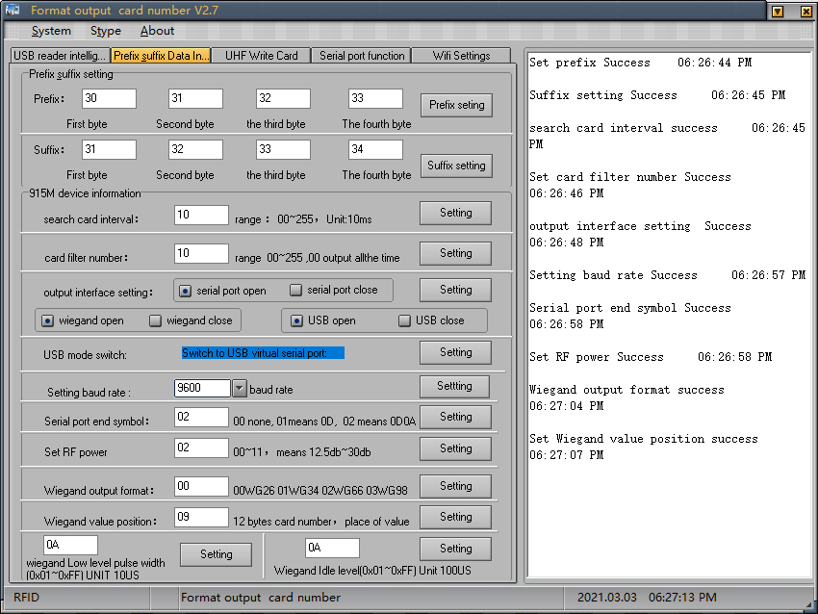

4, configure the card reading mode
4.1 Reader mode switching
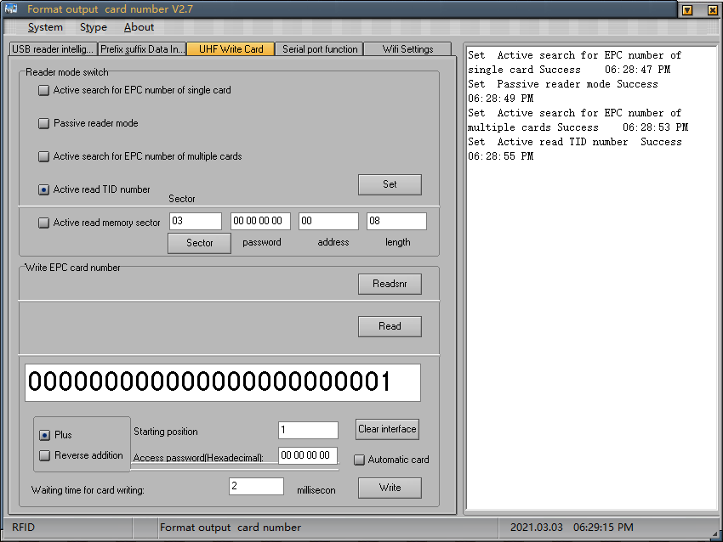
1. Enter the prefix and suffix you want to set, and then click the settings button on the right to confirm
2. When the setting is successful, the results are displayed on the right

4.2 EPC auto-write card
Place the card you want to write within the reader's recognition range and follow the diagram
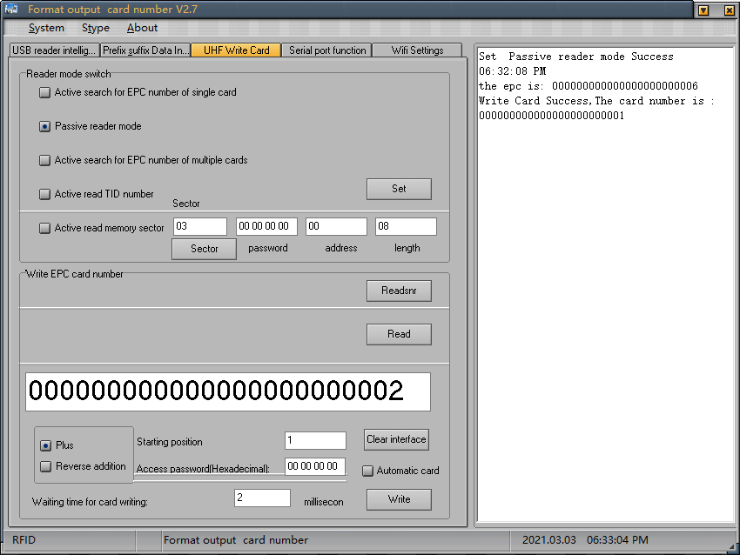
1. Select passive reader mode and click the setting button to complete the setup
2. Click this button after the card is placed in the reader sensing area to read the reader's EPc number
3. Enter the Epc number you want to write here
3. Click on the write card to complete the card writing operation
5, serial data debugging
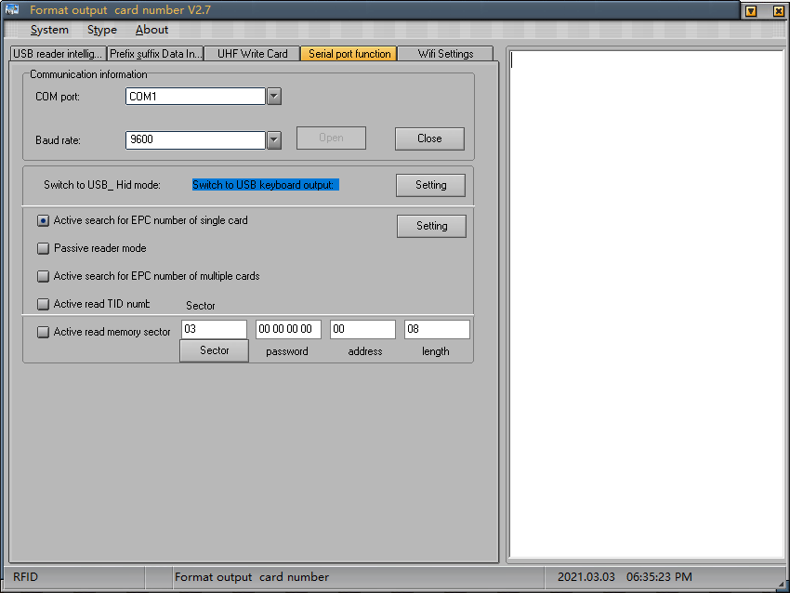
1. When the reader is in the virtual serial output, you can modify the communication information here
3. Set the reading mode here
2. You can switch back to USB keyboard output mode here

6,WIFI function settings
6.1 After connecting to your computer with usb, click Read the WiFi list to see the WiFi you can currently search for, and if you need to connect wiFi in the list, you can connect normally
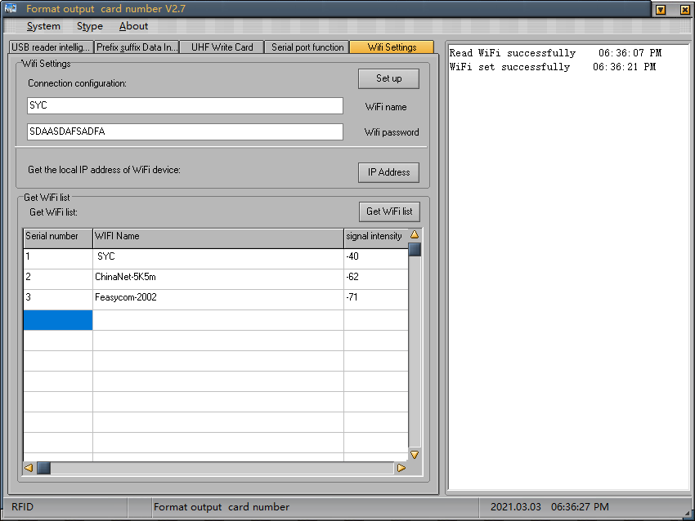
1. Click this button to see a list of WiFi connections
2. The WiFi name that can be searched here

6.2 Confirm that the WiFi name you need to connect to is in the list, fill in the WiFi name and WiFi password in the box of the connection configuration, click Settings, wait 3 to 5 seconds, click read the IP address, and the DEVICE's IP will appear in the right window
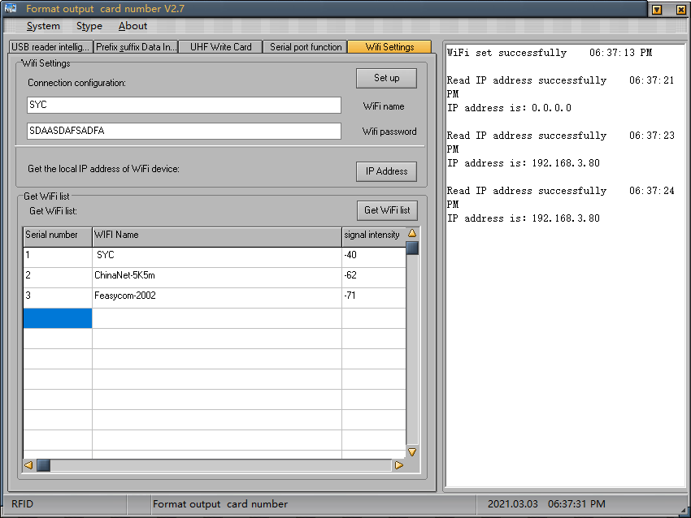
2. Click this button to read the Ip address of this device
3. The results will be displayed here
1. Fill in your WiFi name and password here

Note: If the read IP address is:0.0.0.0, wait 5 seconds for the WiFi connection to re-read, and if it always appears as0.0.0.0, check that the WiFi name or WiFi password is correct and reconnect and try again.

