LF R2D is a 125Khz desktop Reader&Writer of T5577&EM4305 tags. It’s easy to operation, not only can copy the TK4100/EM4100 cards, but also Writable the EM4305/T5577 cards. Widely used for RFID Radio Frequency Identification system and project, Such as charge system, check-ins system etc.
Ⅰ Technical Parameters
Item | Parameters
Model | LF-R2D
Frequency | 125Khz & 134.2Khz
Support cards | T5557、ATA5567、ATA5577、EM4205、EM4305 etc
Size | 104mm×68mm×10mm
Colour | Black
Interface | Virtual serial port(USB to RS232)
Power Supply | DC 5V
Operating Distance | 0mm-50mm(related to the card or the environment)
Service Temperature | -10℃ ~ +70℃
Store Temperature | -20℃ ~ +80℃
Working humidity | <90%
Read time | <200ms
Read interval | ＜0.5S
Weight | About 140G
Cable length | 1400mm
Material of reader | ABS
Operating System | Win XP\Win CE\Win 7\Win 10\LIUNX\Vista\Android
Indicators | Double Color LED (Red & Green) and Buzzer
Ⅱ Instructions for use and Precautions
Step 1 Please install the virtual serial port driver for the first time(Driver name is PL2303);
Step 2 Connect with computer through USB interface directly. When the buzzer sounded, Device into the self-inspection. And the same time, green light turn into red means standby.
Step 3 Openning the Demo(RFID_APP_EN.exe) and Writing the data by self.
Example 1 Copy the Cards(Copy the card data to EM4305 from EM4100 card.)
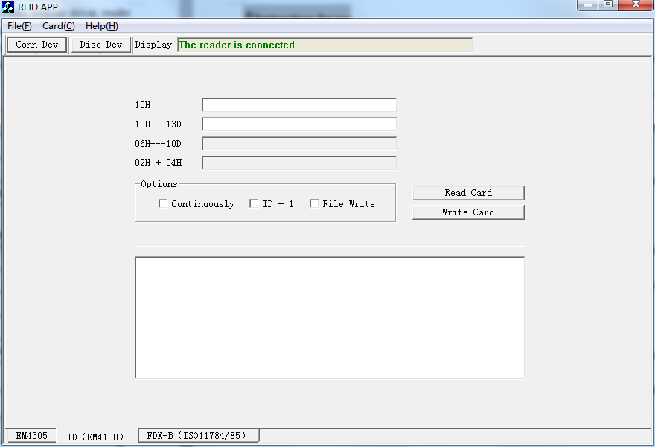
- Connect the device and open the software,then click che command “”. At the same time, the menu has told us that the reader is connected.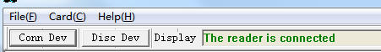
- Choice the card type to “EM4305.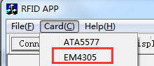
- Write the EM data in the first endit box, the format of data is 10Hex.
- Put on an EM4305 card on the divece and click the “Write Card” command.
Precaution
1) The meaning of options
”Continuously”: Write the same ID number into the EM4305 cards.
”ID+1”:Finish the first card, the ID number of second card will add 1 automatically;
”File Write”: Import data from the a”.txt” file.
2) If your operating system is Win8 or Win10.please updata the driver.
Example 2 Writing the data into the cards of EM4305&T5577
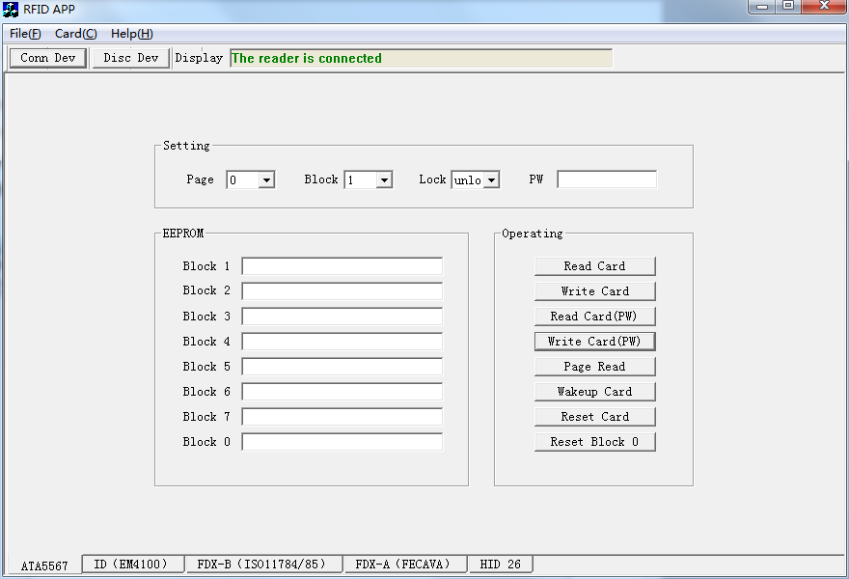
- After the device is connected successfully.Change the type of cards to “ATA5577”.
- Put the T5577 card on the desktop divice.Setting the parameters and click the “Write Card” command.
Precaution
1) T5577 card has 2 pages(page 0 & page 1), different pages has different mean. As follows:
① There are 7 blocks in page 0;
② ”Block 0 ” is an system area, it cann’t be changed this block data;
③ ”Block 7” is Encrypt the card,the content is the password; also, it can ave the data like other blocks that if don’t to encrypt.
2) There are 2 blocks in gage 1,both of them use to save the data .
3） ”Unlock”: if do it, the card data will be changed forever.
4） ‘password’: The User should be write the password in it when reade or write.be
5）Other precaution
① If don’t know the password of the card, the user can get the data through click this command”Page reader”;
②”Reset Block 0”: Factory Reset is means delete the data of the card that including the encryption cards, but cann’t reset the lock cards.
6） Every reader or write is after all parameters be setted.
Ⅲ Pictures
